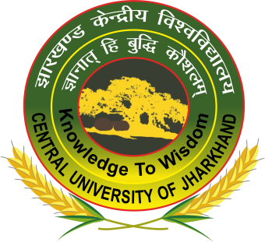 |  | Online Faculty Development Program  On  “Quest Abound with Radiation Around: A Webinar on Cross Disciplinary Endeavours in Radiation Science  7th - 11thDecember 2020
Organized by
Department of Physics, Central University of Jharkhand,
Cheri-Manatu, Kamre, Kanke, Ranchi, Jharkhand-835222
7th December 2020
15:00 : 16:15 | Inauguration  Welcome Address by Prof. S. Medhekar,Chairman , FDP  Address by Prof. Arun Kumar Padhy,Dean , School of Physical Sciences, CUJ  Address by Prof. Manoj Kumar, Professor (I/C), CUJ  Address by Prof. S. L. Harikumar, Registrar, CUJ  Inaugural Address by Prof. R. K. Dey, Vice Chancellor (Acting) CUJ  Keynote by Address, Dr. Amit Roy, Former, Director, IUAC, New Delhi  Vote of Thanks, Dr. Dharmendra Singh, Convener &Head, Department of Physics, CUJ
16:30 – 17:00 | Dr Abhijit Saha, UGC DAE CSR, KC (Use of gamma rays to understand the nano world )
8th December 2020
15:00 – 15:30 | Dr.DebasisMitra, University of Kalyani (Use of x-ray studies for societal relevance.)
15:40 – 16:10 | Dr. S. Santra, BARC. (Coulomb Excitation : Insights into nuclear structure)
16:20 – 16:50 | Dr. R. P. Singh, IUAC (INGA : The journey so far )
9th December 2020
15:00 – 15:30 | Dr Ram Janay Choudhary, UGC DAE CSR, Indore Centre (Synchroton Radiation for material characterization)
15:40 – 16:10 | Prof R Palit, TIFR (Nuclear Structure : New frontiers)
16:20 – 16:50 | Dr. P. Sugathan, IUAC. (Multidetector arrays for neutron studies)
10th December 2020
15:00 – 15:30 | Dr. Tilak Ghosh, VECC (Gas Detectors and their relevance in fission studies)
15:40 – 16:10 | Dr.Sankha Chattopadhyay, BRIT (Medical Cyclotron : An over view)
16:20 – 16:50 | Prof Indranil Mazumdar, TIFR (What have we learnt from GDR studies )
11th December 2020
15:00 – 15:30 | Dr. V. Siruguri, UGC DAE CSR, Mumbai Centre (Use of neutrons for material characterization)
16:40 – 16:10 | Dr Rahul Tripathi, BARC. (Lessons learnt from the study of incomplete fusion reactions)
16:20 – 16:50 | Dr. R. Raut, UGC DAE CSR, Kolkata Centre (Digital high way)
Dr. Dharmendra Singh, Department of Physics ,
Central University of Jharkhand, Ranchi-835222, Jharkhand, India.
Email: fdpdop2020@gmail.com
Mobile: 8809323825

